Medicare Application

Actor or type of users.

Admin

Sign In no SignUp

[admin@gmail.com](mailto:admin@gmail.com)

admin@123

Admin Dashboard

Medicines

Mid, name, price, qty, description, image etc.

Add, Display, Delete and Update

Filter by Price(Asc/Desc), By name(A to Z)

Admin can view all customer order details.

User Or Customer

Sign In

Sign Up

Dummy account

Accno, amount 🡪 500 rs

Customer Dashbarod

Medicines

View All Medicine details using images

Add those medicine details in cart and place the order.

Search : by name or etc .

Filter by Price(Asc/Desc), By name(A to Z)

Customer can view its own order details.

Backend 🡪 Spring boot

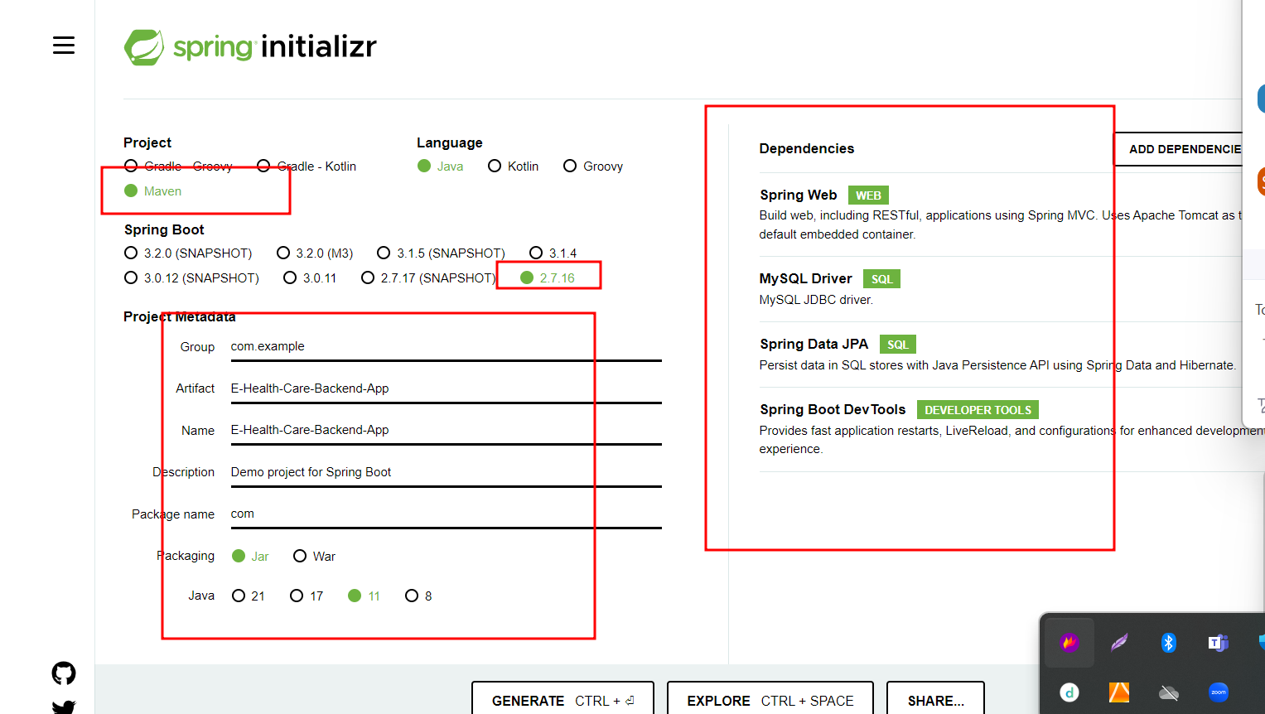

In Java or using spring boot

We can connect database using

1. Jdbc
2. Hibernate
3. JPA
4. Spring Data

Backend 🡪 spring boot

Frontend 🡪

Angular app

Frontend backend -----------------🡪Database

Angular application <------------------------🡪 spring boot MySQL

Ng g c login -🡪 login component

Ng g c signup 🡪sign up component

Ng g class login -🡪 normal typescript class

Ng g s login -🡪 login service

Ng g c admindashboard -🡪admin dashboard component

Ng g c customerdashboard 🡪customer dashboard component